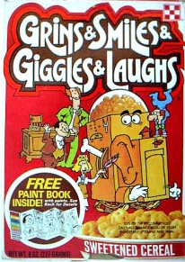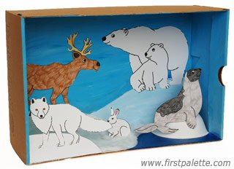
Cereal Box Commercial & Animal Science Project Demonstration
Thursday, November 21, 2013
at 9:00 a.m.

• Please come out and join us as your child presents their Cereal Box Book Report. Students will present their Cereal Box Book Report in the form of a Commercial. The student's objective is to “sell” their Cereal Box (Book Report) in such a manner as to persuade you to want to buy the Cereal (read the book).
• We would also like parents to donate cookies and punch for you all to enjoy during the presentations.
• We look forward to you coming.
• Also, Mrs. Lewis will give instructions about the student’s Animal Science Project. She will give a brief demonstration of how to make the Diorama part of the student's Animal Project.

Thanks
K. Springer & L.Lewis
tear off & give to teacher

____ Yes, I can come watch my child’s presentation on Th, 11/21

____ No, I can’t come watch my child’s presentation on Th., 11/21

My child’s name is _____________________________________________

