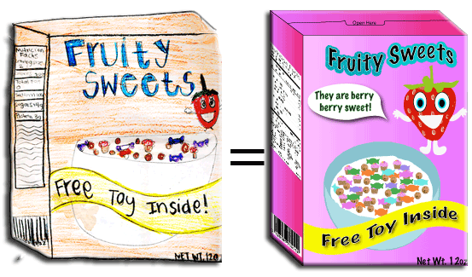

From the Desk of:
Mrs. K. Springer
10/1/2013
Cereal Box Book Report 

This week students have been studying realistic fiction. This quarter students will select a teacher-approved realistic fiction book. Over the next 2 1⁄2 weeks, students will read their self-selected book and create a cereal box book report at home. Students will decorate a real cereal box with illustrations and information related to the book they read using the directions below.

FRONT OF BOX:
Use a piece of white or light colored paper to cover the front of your cereal box. (You will probably want to create the cover before gluing it on your box.) Include the name of the cereal and a picture. Invent a name for the cereal that is related to the title of the book and sounds like a cereal. Do not use the exact title of the book. Choose a shape for the cereal as well as colors and ingredients that all relate to the book. For example, for Harry Potter and the Sorcerer's Stone, you might invent a cereal called Wizard Wands, a toasted oat cereal in the shape of miniature lightning bolts.

RIGHT SIDE:
Make a list of ingredients that includes the story elements Characters and Setting. Under the heading "Ingredients," list the main characters and write a sentence about each one. Then describe the setting. You can use the template on the attached sheet or cover the side with white or light colored paper and do it in your own way. Just make sure you include the main characters and the setting
LEFT SIDE:
Write a summary that describes the main problem and the solution of the book. Try to use words that will “grab” readers’ attention and make them want to buy your cereal. You can use the attached template or do this is your own way.

BACK OF BOX:
Design a game that is based on the story. It can be a puzzle, a word search, a word scramble, a maze, a crossword puzzle, a hidden pictures illustration, or any other fun activity that might be found on the back of a cereal box. Make sure it includes information from the book.

TOP OF BOX:
Include the title, author, number of pages, and number of stars you would give this book if you were a book critic. The maximum number of stars would be 5. You can use the template or create the top of the box yourself as long as you include all of the things listed above.

PRIZE:
Cereal boxes often include a prize. Your prize must be something the main character could have used in the book or something that reminds you of the main character. You can even include a picture of the prize on the front of your box to let the reader know what is inside the box.

YOUR CEREAL BOX BOOK REPORT IS DUE AT SCHOOL ON Tuesday, Oct. 29, 2013.

**All templates for this cereal box book report will be available to download from the class website. This will be helpful for students who want to write rough drafts for the sides of their box before doing the final copies. Also, if students mess up or want to redo any section of the box, they can just print new copies from the website. If students need any glue, scissors, markers, white paper, colored paper, or construction paper from school, they are more than welcome to borrow those materials upon request.
Cereal Box Commercial
Students will share their project by doing a 1-2 minute commercial for their cereal. These oral presentations will be made on March 8th. Students should practice their commercials at home to make sure of the timing. The goal is to make other students really want to buy the cereal (read the book). Use the following guidelines for writing the commercial:
Share exciting elements from the book – the problem, important scenes, interesting characters, etc. Be energetic! Try to convince the audience to buy the cereal whether you liked the book or not. • Cereal has nutritional value and is “good for the body.” Tell your classmates why this book would be good for them! •
(Optional) Be a character from the book to help you “sell” your product.
__________________________________________________________
__________________________________________________________
__________________________________________________________
__________________________________________________________
__________________________________________________________
This sheet is only for planning purposes. If you prefer to type your commercial or write it on index cards, that is fine. You will not need to turn in a draft of your commercial. Your grade on this part of the project will be based on how well you present your commercial to the class.

